Nama : Raihan Rahmanda Junianto

NIM : 222112303

Kelas : 2KS4

**Responsi Praktikum 12 Pemrograman Berbasis Web**

1. **Instalasi Postman**

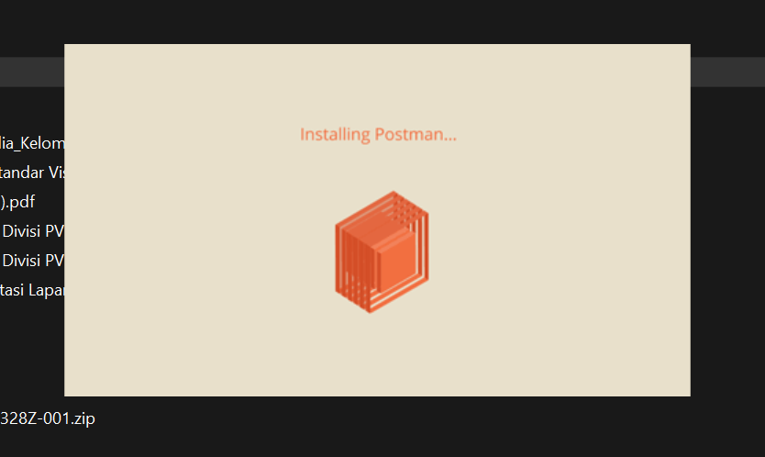

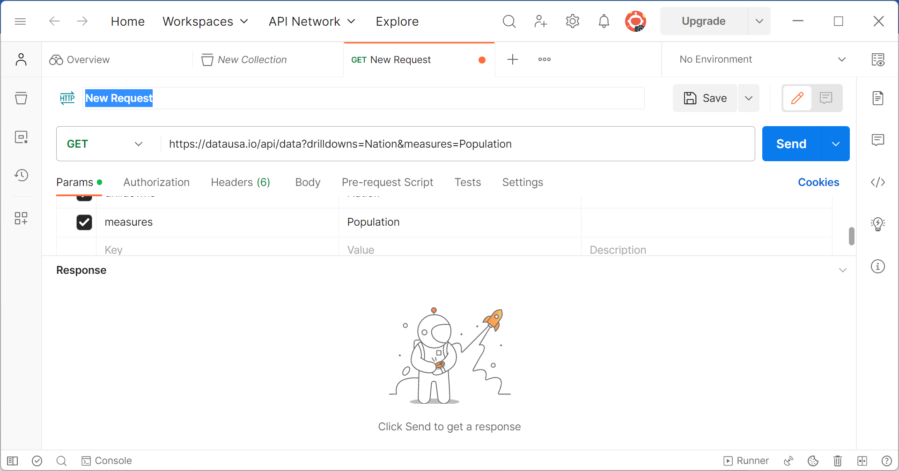

1. **Membuat REST API dengan Method GET**

* **Tampilan Output di Browser dan Postman**

* **Tampilan Request dalam Bentuk JSON**

* **Menampilkan data tertentu dari tabel**

1. **Membuat REST API dengan Method POST**

1. **Membuat REST API dengan Method PUT**

1. **Membuat REST API dengan Method DELETE**

1. **Mengakses REST API menggunakan PHP**

* **Menggunakan fungsi file_get_contents()**

* **Menggunakan library cURL**

